March 15, 2023 report – Thea Gregory 5291240

Today I worked on the following:

* Completed the UML diagrams for the project. I have organized this by placing each use case in its own separate tab, allowing me to isolate each part of the MVC design pattern so I can refer to it quickly and easily.

I am pleased with this progress because this means that this afternoon I can begin creating the MySQL database and writing the logic for the login feature to test my MVC plans. I have also created my UML in an organized way, which means I will not be confused later on in the project when I need to refer to it.

Screenshots:

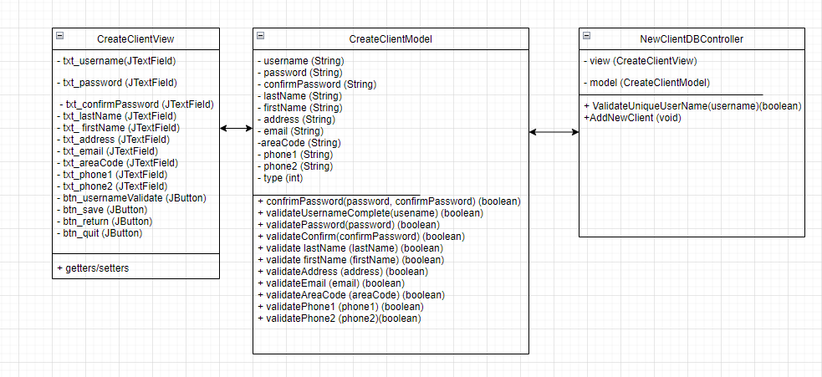

List of MVC types I mentioned above:



